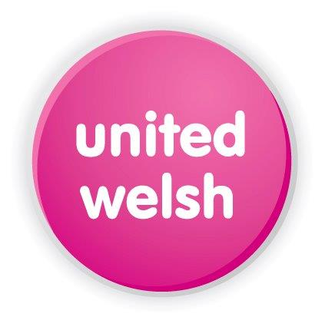

Equality, Diversity and Declaration of Interest form

The United Welsh Group promotes and delivers equality as an integral part of who we are and what we do.

We are committed to the principles of equality, diversity and inclusion in employment and the provision of our services, and fully embrace all elements of the Equality Act 2010.

We value diversity in experiences and backgrounds so that our staff can create better outcomes for our communities. When we recruit for vacant posts, we encourage applications from all members of the community.

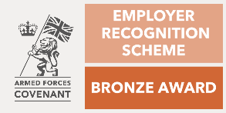
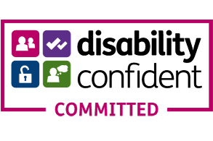

As part of our Deeds Not Words pledge to end racial inequality in housing, we have implemented the Rooney Rule. This means that minority ethnic applicants who meet the essential criteria, as outlined in the Job Profile, will be invited to interview.

We are a Disability Confident Committed employer. This means we strive to make each stage of our recruitment process inclusive and accessible for all. We actively encourage applications from people with disabilities and we are committed to ensuring that applicants who meet the essential criteria, as outlined in the Job Profile, will be invited to interview.

We hold the Bronze Standard in the Armed Forces Covenant. This means we promote being armed forces-friendly and we are open to employing reservists, veterans, cadet instructors and military spouses / partners. We are committed to ensuring that these applicants who meet the essential criteria, as outlined in the Job Profile, will be invited to interview.

About you

We would be grateful if you could answer the following questions to allow us to assess the diversity of applications. The information you provide will be used for monitoring purposes only and will be kept separate from your application.

Please enter your National Insurance number here:

__________________________________________________________

To ensure that we comply with our governance obligations, please answer the following questions by putting an ‘x’ in the relevant box.

- Are you related to or do you know any board members or employees of United Welsh?

Yes [] No []

If you have answered ‘Yes’ above, please state who and the nature of the relationship:

- Are you involved in / or do you have any close relatives owning a profit-making business which works with United Welsh?

Yes [] No []

If you have answered ‘Yes’ above, please provide details here:

Are you a tenant of United Welsh/live in a United Welsh property? Yes []

- Have you previously been employed by United Welsh?

Yes [] No []

Equality and Diversity in employment

- How would you describe your ethnic origin?

- Please let us know if you wish to have the Rooney Rule considered as part of your application process:

Yes [] No []

- How would you describe your national identity?

- What is your gender identity?

Disability and Adjustments

- Do you have a disability?

Yes [] No []

If yes, would you like your application to be considered as part of the Disability Confident scheme?

Yes [] No []

- Do you require any adjustments or support to assist you during the recruitment process?
Yes [] No []

If you have answered ‘Yes’ above, please give brief details of any adjustments that you may require at interview or assessment:

Armed Forces Covenant

Do you wish for your application to be considered under our Armed Forces Covenant?

Yes [] No []

Thank you for taking the time to complete this part of the job application.

Prior to submitting your application, please ensure all information that you provide is accurate.

